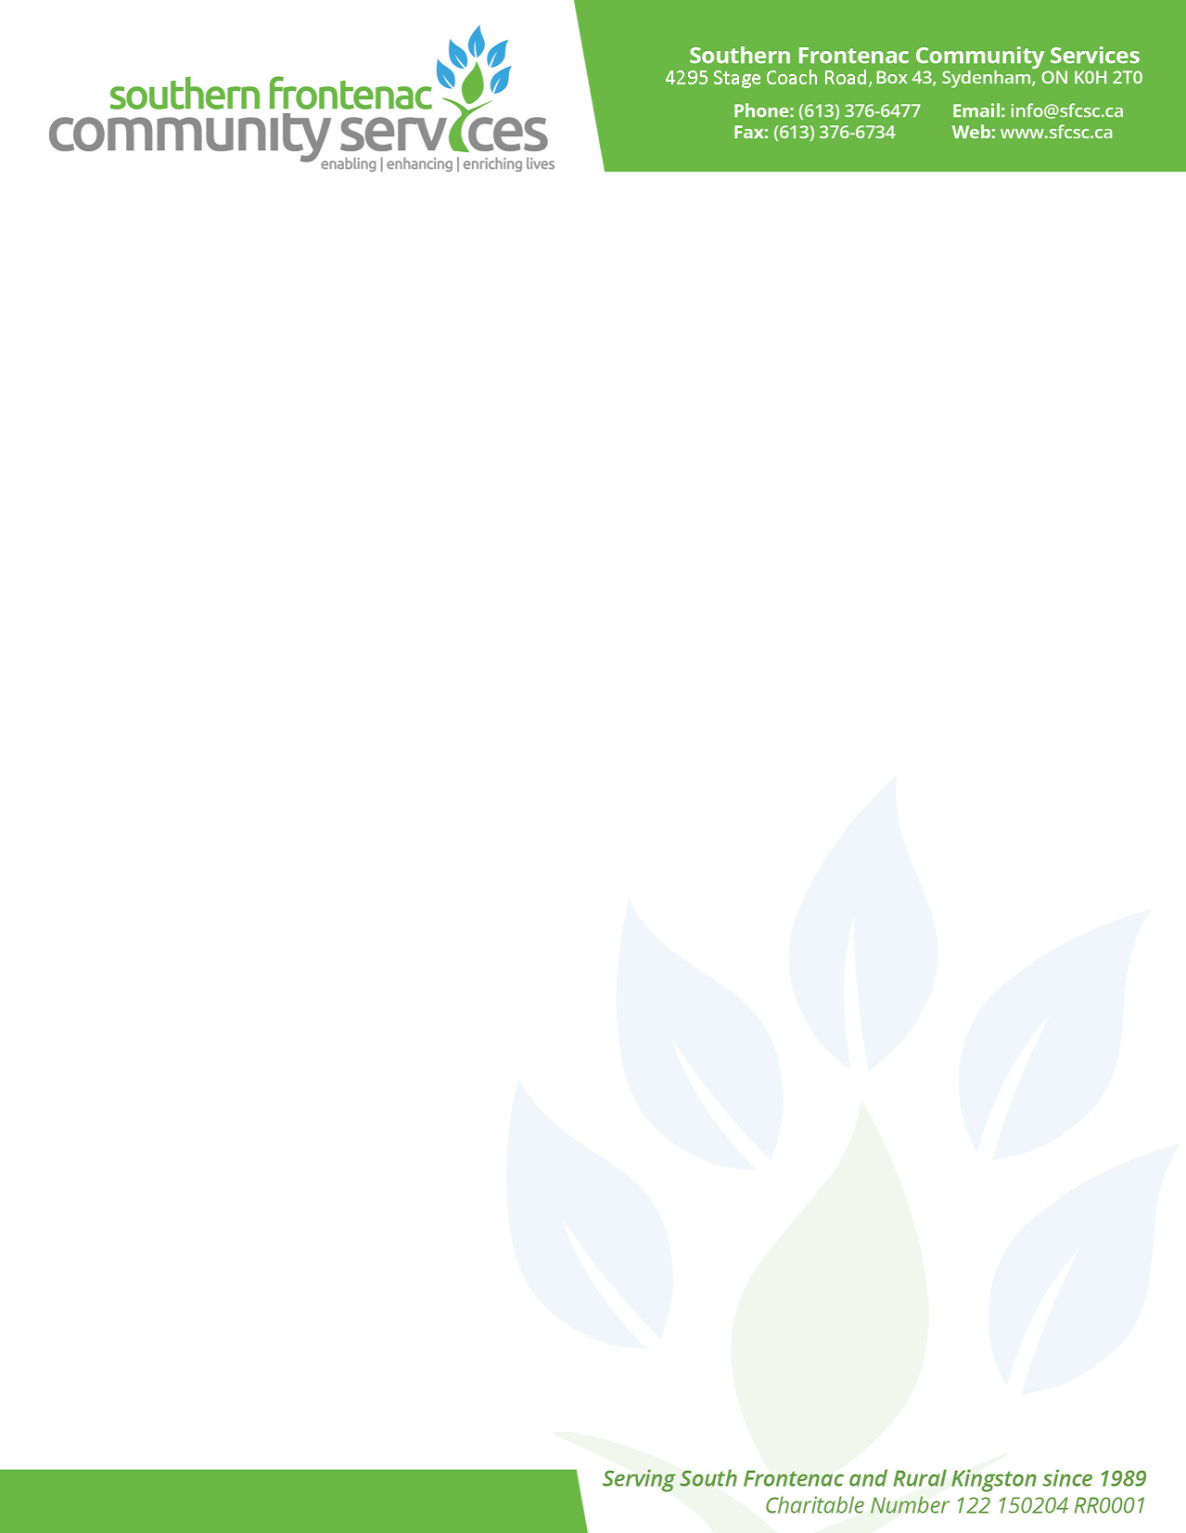
Warm Feet Project

Southern Frontenac Community Services wants to make sure every school-age child in our region (age 4 - 15) has a pair of warm boots for the winter. The Warm Feet Project is intended to support families with limited income who otherwise may be unable to purchase winter boots. Families must be referred to Southern Frontenac Community Services to participate in this program. Referrals may come from your children’s school, doctor, church, or other organization.

We receive a limited amount of funding from United Way to purchase boots. We cannot guarantee that all requests can be filled, but we will do our best. Sorry, no toddler/baby boots, and child must be 15 or under.

Applications are due no later than Friday, September 30, 2025. Please return to your school by the deadline. If you have any questions or concerns regarding the Warm Feet Project, please do not hesitate to contact Jody Riddle, Family Services/Food Bank Coordinator at 613-376-6477 ext. 203 or email jody.riddle@sfcsc.ca

WARM FEET APPLICATION
Referral organization:

Contact Name: |  | Phone:
Part A: Family/ Guardian Information
First Name |  | Last Name
Address:

Phone Number |  | Email
Child’s Name | Age (must be  4 - 15) | Girl or Boy |  | Boot Size

